Please Read this Notes:

1. In the workbook “FruitSoul Demand Log.xlsx” the last three columns are still using formulation. Please copy and paste as a number to fix the number before doing any data manipulation.  
   

If you do not copy or paste as fixed number, the data will change if you do any operation on that data.

1. In task 1.1 – 1.4 you may have different graph combination

|  |  |  |
| --- | --- | --- |
| Product | State | Time |
| 27 (distinct mix and size) | 51 states | Daily |
| 27 (distinct mix and size) | Country (Aggregated) | Daily |
| 1 (Aggregated) | 51 states | Daily |
| 1 (Aggregated) | Country (Aggregated) | Daily |

We know this might be a lot of graphs, but you may show 5-6 graphs in your report.

But please make sure your code/excel file shows the expected results with minimal intervention if we want to check it like changing the filter in code, etc.

1. Task 1.5 ***Smoothed demand delivery history: how many products units are estimated to have their delivery demand potentially realized in each day. The smoothing exploits the distinct earliest, preferred, and latest dates, to spread each product unit demand into demand fractions for each of the feasible day.***

You are given 3 dates, in which the delivery date for that order can be chosen within the date of the of latest delivery date to earliest delivery date. In this task you need to leverage this information so that the quantity customer expected within the same date is stable or smooth.

Please find the example: This is the initial demand based on latest delivery date versus the smoothed date



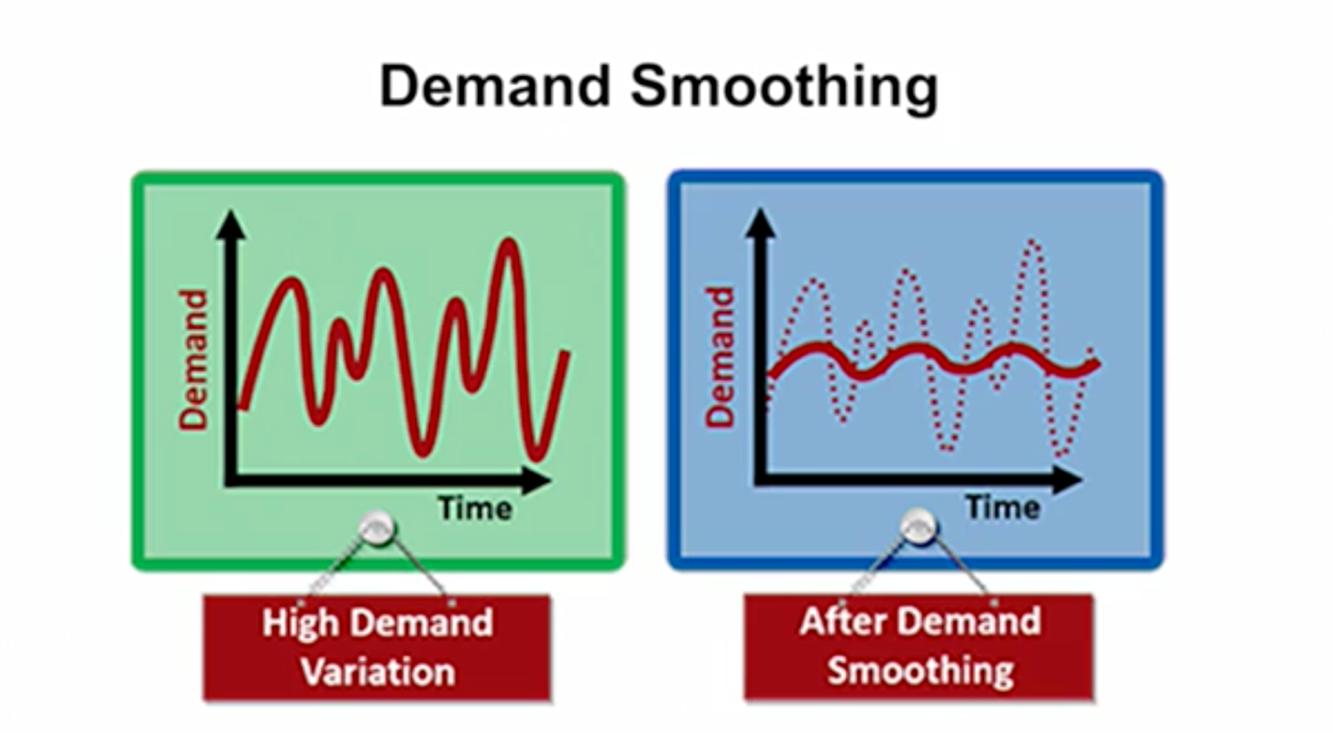

Source: Linkedin Learning by Laurence Gartside, **[Demand and Capacity Management for Operations](https://www.linkedin.com/learning/demand-and-capacity-management-for-operations?u=2163426)**

1. Task 3

Demand share of each product means:

* 27 distinct products,
* 9 mixes and
* 3 jar sizes

1. Task 5 à you will need to calculate the expected shipping date from the warehouse given the estimated delivery time from the warehouse to customer.
2. Rack size 96X36X120 inch3 is for 10 tier shelving, so every tier will be 96X36X12 inch3.